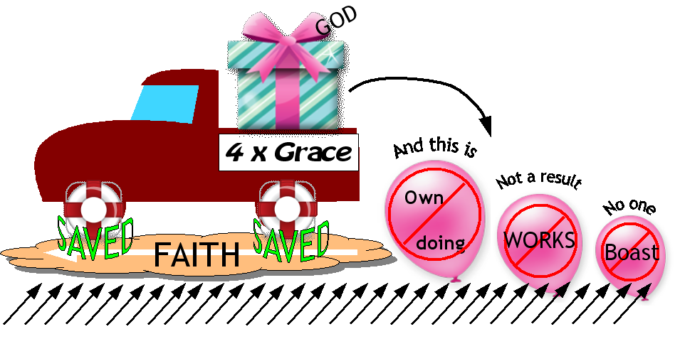

Ephesians 2:8-9
8 For by grace you have been saved through faith. And this is not your own doing; it is the gift of God, ⁹ not a result of works, so that no one may boast.

